Why Did the Communists Win the Chinese Revolution?

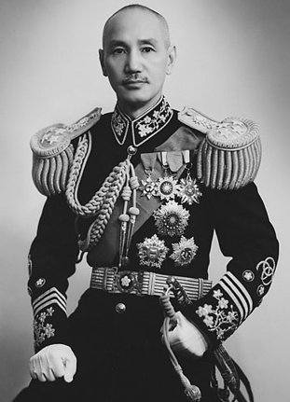
From 1911 to 1945, China experienced a revolution, a struggle against warlords, a civil war between the Nationalists led by Chiang Kai-Shek and the Communists led by Mao Zedong, and invasion by the Japanese. After the defeat of the Japanese in World War II in 1945, a full-blown civil war erupted again in 1946. The Nationalists were backed by the United States and the Communists had support from the Soviet Union. By 1949, Chiang and the Nationalists, despite having more soldiers than the Communists, were defeated and forced to evacuate the Chinese mainland for the island of Taiwan.
Chinese nationalist leader Chiang Kai-Shek.

Historians point to a number of factors for the Chinese defeat.

Chiang’s Kuomintang government was filled with incompetent and corrupt officials. The people especially hated the tax collectors, who were commonly called “blood-sucking devils.” Chiang himself held dictatorial powers, but his orders were often ignored. He had little success in rallying Chinese nationalism to win an unpopular war against the Communists.

Chiang’s decision to go to war against the Communists in 1946 came at the cost of postponing the economic reconstruction of China. This meant diverting tax revenues, investment, and other resources to the war effort rather than to the needs of the people. Heavy taxes, a huge government debt, inflation, unemployment, and food shortages caused many, especially in the cities, to lose faith in the Nationalist government.

Economic discontent in the cities led to thousands of labor strikes. Students, newspaper editors, and intellectuals protested against Chiang’s Nationalist government. They demanded an end to the civil war and the creation of a government that included the Communists. The Nationalists responded with censorship, beatings, mass arrests, and even assassinations. This repression drove many to the Communist cause.

The Nationalist government seemed to care only for city business interests and rural landlords while ignoring the suffering of the peasants. In Communist areas captured by the Nationalists during the early part of the civil war, corrupt government administrators helped landlords take back lands that the Communists had handed over to the peasants. The government often punished peasants for participating in Mao’s land-distribution programs.

Chiang’s army had more soldiers than Mao’s, but it was poorly led. Chiang’s military was not coordinated by a central command. Generals tended to head independent armies and even competed with one another for food and ammunition. Many officers were corrupt, sometimes selling for personal profit the rice intended for their troops. Chiang’s military supply sys- tem was inadequate, unreliable, and crippled by corruption.
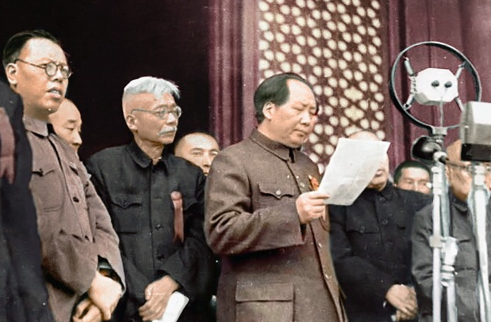
More important, few volunteered to join Chiang’s armies. Most soldiers were drafted against their will or even kidnapped by army “recruiting squads.” Soldiers were poorly trained, clothed, and fed. Officers enforced discipline by beating them. Some were roped together on marches to prevent them from deserting.
Mao Zedong declares the founding of the People's Republic of China, October 1, 1949.
Communist propaganda took full advantage of all the Nationalist failings. Mao focused on winning over the peasants to gain their support in the civil war. “The battle for China,” he said, “is a battle for the hearts and minds of the peasants.”

Whenever the Communists secured an area during the civil war, Mao’s cadres (teams of supporters) went to work, organizing village “struggle meetings.” Peasants and laborers, who owned little or no land, met to force wealthy landlords to confess their bad treatment of the poor. This sometimes included torturing, beating, or even killing landlords as “enemies of the people.”

The cadres then cancelled all debts owed to the landlords and distributed their land and other property to the poor peasants and laborers. What they received became their own private property.

As more peasants and laborers acquired land, more of them had a stake in the success of the Communists. If the Nationalists won the civil war, the new landowners understood they would lose everything the Communists had handed over to them. As a result, they increasingly supported Mao’s army with food, labor, transportation, and soldier recruits. Most of these people were not dedicated Communists but now they had something to fight for. Mao had an even greater reason to confiscate and re-distribute land from the landlords to the poor peasants and laborers. In doing so, he destroyed the traditional landlord power structure in the villages and replaced it with new peasant leader ship under the control of the Chinese Communist Party.

Land reform built Mao’s peasant revolution to transform China into a Communist society. As he kept reminding his cadres, land reform was “the mother of all other work.”

Unlike Chiang’s numerous independent armies, Mao’s People’s Liberation Army (PLA) was unified under a tightly controlled central command. Mao’s generals, dedicated to the Communist cause, were superior military leaders. They transformed small guerilla bands into a modern conventional army capable of moving quickly to take advantage of the much larger but uncoordinated Nationalist armies.

PLA officers treated ordinary soldiers with more respect than the soldiers got in Chiang’s armies. PLA soldiers were also more motivated than Chiang’s troops. During the civil war, hundreds of thousands of individual Nationalist soldiers deserted, surrendered, or defected to the Communists.

The Aftermath
Chiang established a new Kuomintang government on Taiwan, but claimed he was still the president of all China. Likewise, Mao declared that Taiwan was part of the People’s Republic of China. This political conflict over Taiwan’s status remains unresolved to this day.

As the Chairman of the Chinese Communist Party, Mao possessed absolute power. To purify the Communist revolution in China, he ordered political purges, mass imprisonment, and executions of “enemies of the people.” By 1955, Mao had forced the peasants to give up their privately owned plots of land to form state-owned collective farms. The peasants then worked for the government. A few years later, Mao ordered the peasants to work on even larger communes. Food production plummeted, and many Chinese starved.

Millions died as a result of Mao’s policies. Later, in 1976, claiming that elements of Chinese society were trying to undermine communism, Mao declared the Cultural Revolution. Red Guards and armies of students ravaged the countryside beating and humiliating those suspected of countering the revolution. Thousands of historic Chinese sites and books were destroyed. People were forced from the cities into the countryside for “re-education. Estimates of deaths caused by the Cultural Revolution range from a low of 400,000 to over 5 million.

Chiang Kai-shek died in 1975, and Mao Zedong died the next year. Following Mao’s death, China began to adopt free-market reforms that introduced elements of capitalism into its economy. As a result, the People’s Republic of China today has greatly improved the standard of living, health and nutrition of the people and the Chinese economy is now the second largest in the world. The Chinese Communist Party, however, still holds a monopoly of power. It does not tolerate political dissent or anyone who questions its right to rule.

For Discussion
- What might Chiang Kai-Shek and the Nationalists have done to improve their chances of winning the civil war?

- Some believe that Mao was the worst mass murderer of the 20th Century. If this is true, would the Chinese have been better off if the Nationalists had won the civil war?

Graphic: Chiang Kai-shek, 1942
https://en.wikipedia.org/wiki/Chiang_Kai-shek#/media/File:Chiang_Kai-shek%EF%BC%88%E8%94%A3%E4%B8%AD%E6%AD%A3%EF%BC%89.jpg

Graphic: Mao Zedong declares the founding of the modern People's Republic of China, October 1, 1949. https://en.wikipedia.org/wiki/Mao_Zedong#/media/File:Mao_Proclaiming_New_China.JPG

