When England Industrialized

Today’s world is experiencing rapid economic changes. Some call it the end of the Industrial Revolution and the beginning of the Technological Revolution. Industrial countries such as the United States have seen production move overseas where labor is cheaper. Other jobs have been lost to automation when new technologies and computers replace workers. Many workers lack the technological skills to get hi- tech jobs and have to take lower paying service jobs. These changes affect millions of peoples’ incomes and lives. Two centuries ago, the Industrial Revolution also brought many changes.

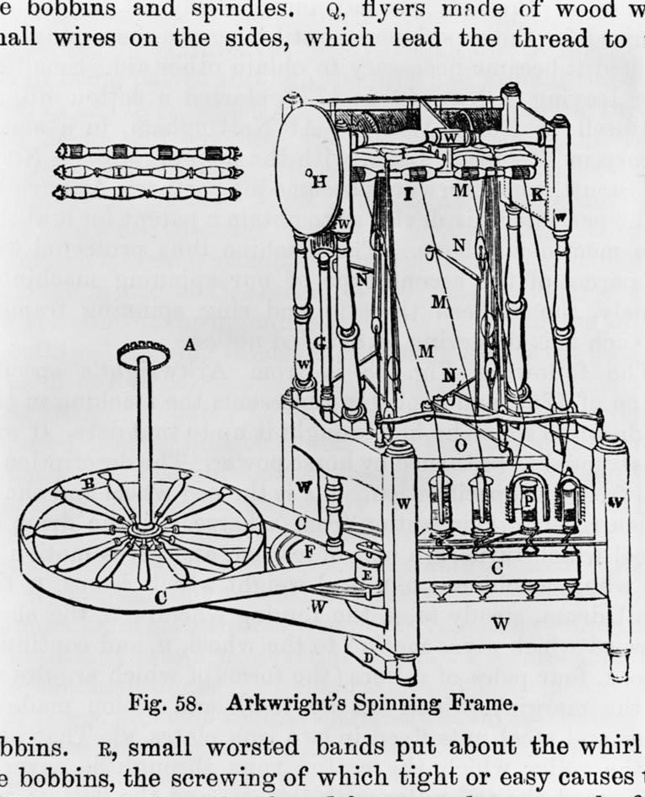
After about 100 years of industrialization, by 1850 Great Britain was known as the “workshop of the world.” A small country in size and population, it was producing about two-thirds of the world’s coal and more than half of its iron and cloth. And while government representatives and businessmen from throughout Europe were touring Britain’s industrial centers and sending home reports, the rest of Europe was still far slower than the British in industrializing.

Manchester had become Britain’s leading industrial city. A hundred years earlier, Manchester was only a small town, with a population of approximately 10,000. Then, in 1783, Richard Arkwright built a steam- powered cotton mill in Manchester, and within in a few years, new mills with steam-driven machinery dotted the area. By the turn of the century, the cotton industry had exploded. In just 20 years — between 1780 and 1800 — imports of raw cotton increased from 6 million to 56 million pounds per year. Cotton mills sprouted up everywhere as did warehouses to store cotton and finished products. In 1806, the city center housed just over 1,000 warehouses, and 15 years later, this number had almost doubled. By 1821, the city contained 32 factories with 5,722 steam-powered weaving looms. Manchester was called the “warehouse city” and later became known as “Cottonopolis” and the world’s first center of mass production.

People came from all over the world to see the new industrial world. Much of what they saw was ugly, because England had not figured out how to manage its growing population in cities (urbanization).

Manchester’s population grew from 25,000 in 1772 to 455,000 in 1851. Heavy soot from burning coal blocked sunlight and blackened the city, as it did in other factory cities. Other problems arose — a lack of police protection, clean water, sewers, garbage disposal, and housing. Families lived in single rooms, and ragged children roamed the filthy streets. The factories paid reasonable wages for unskilled workers, but not enough to support a whole family. The work-day was long, and the work was tedious. Many factories hired children as young as 6 years old.

In 1835, Alexis de Tocqueville, a French political writer and historian, went to Manchester, which he called “the palace of industry.” He found a city with 30 or 40 huge six-story factories, where the “noise of furnaces (and) the whistle of steam fill the air;” where “300,000 human beings are ceaselessly at work” and where a few are wealthy and many are poor. Summing up, de Tocqueville wrote:

From the foul drain the greatest stream of human industry flows out to fertilize the whole world. From this filthy sewer pure gold flows; here humanity attains its most complete development and its most brutish; here civilization works its miracles and civilized man is turned almost into a savage.

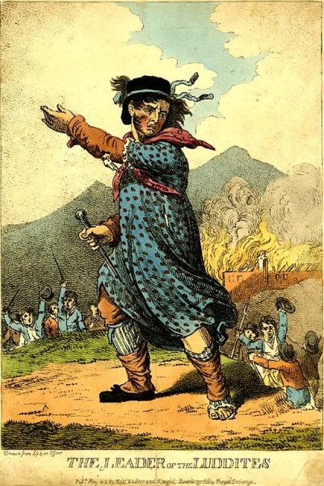
The transition from an agricultural economy, where farmers and villagers set their own routines, to the machine-driven routine of 12-hour shifts in huge factories, did not come easily to many British workers. And some workers fought back. Skilled textile artisans, who had spent years perfecting their skills of weaving cloth on hand-worked looms, were put out of work by automated looms and replaced by unskilled workers. Unskilled factory workers received much lower pay.

Skilled workers organized themselves into groups and began violent protests in 1811. They burned weaving factories or destroyed the automated looms and weaving machinery. These protestors, called Luddites, became so violent that the British army had to be called into action leading to bloodshed as the protests were put down. The British government also passed new laws against “machine breaking,” that could result in the death penalty or penal servitude. Mass trials of Luddites led to convictions and by 1813 the movement was crushed.

Today, the term Luddite has taken on the meaning of someone who is against automation such as the use of computers and machines. But some historians argue that the original Luddites were not against machines per se. They opposed the low wages that workers received who worked at the machine-driven looms. In this way, the Luddites were an early labor movement fighting a system of low wages.

Eventually the Industrial Revolution and reforms fought for by the organization of labor brought the common man less expensive goods and products, more comfortable living conditions, better nutrition, and longer life.

For Discussion

- What were the benefits and costs of industrialization in England?

- Were the Luddites fighting against the changes brought on by the industrial age or for a return to higher wages?

- Were the Luddites’ protests justified?

Graphic: Detailed design for a large thread spinning machine. Library of Congress. https://www.loc.gov/item/2006691761/

Graphic: Leader of the Luddites. Wikipedia. https://upload.wikimedia.org/wikipedia/commons/7/73/Luddite.jpg

