Social Darwinism and American Laissez-faire Capitalism
British philosopher Herbert Spencer went a step beyond Darwin's theory of evolution and applied it to the development of human society. In the late 1800s, many Americans enthusiastically embraced Spencer's "Social Darwinism" to justify laissez-faire, or unrestricted, capitalism.
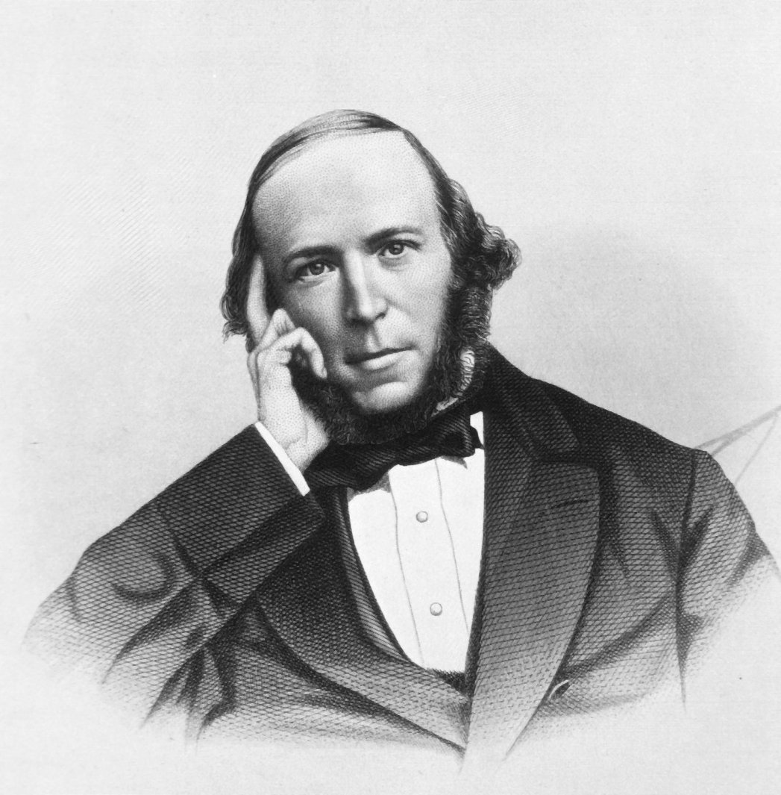
In 1859, Charles Darwin published Origin of Species, which explained his theory of animal and plant evolution based on "natural selection." Soon afterward, philosophers, sociologists, and others began to adopt the idea that human society had also evolved.
The British philosopher Herbert Spencer wrote about these ideas even before Darwin's book was published. He became the most influential philosopher in applying Darwin's ideas to social evolution. Born in 1820, Herbert Spencer taught himself about the natural sciences. For a brief time, he worked as a railroad surveyor and then as a magazine writer. Spencer never married, tended to worry a lot about his health, and preferred work to life's enjoyments.
In 1851, he published his first book. He argued for laissez-faire capitalism, an economic system that allows businesses to operate with little government interference. A year later, and seven years before Darwin published Origin of Species, Spencer coined the phrase "survival of the fittest."
Darwin's theory inspired Spencer to write more books, showing how society evolved. With the financial support of friends, Spencer wrote more than a dozen volumes in 36 years. His books convinced many that the destiny of civilization rested with those who were the "fittest."

The "Fittest" and the "Unfit"
Herbert Spencer based his concept of social evolution, popularly known as "Social Darwinism," on individual competition. Spencer believed that competition was "the law of life" and resulted in the "survival of the fittest."
"Society advances," Spencer wrote, "where its fittest members are allowed to assert their fitness with the least hindrance." He went on to argue that the unfit should "not be prevented from dying out."
Unlike Darwin, Spencer believed that individuals could genetically pass on their learned characteristics to their children. This was a common, but erroneous belief in the 19th century. To Spencer, the fittest persons inherited such qualities as industriousness, frugality, the desire to own property, and the ability to accumulate wealth. The unfit inherited laziness, stupidity, and immorality.
According to Spencer, the population of unfit people would slowly decline. They would eventually become extinct because of their failure to compete. The government, in his view, should not take any actions to prevent this from happening, since this would go against the evolution of civilization.
Spencer believed his own England and other advanced nations were naturally evolving into peaceful "industrial" societies. To help this evolutionary process, he argued that government should get out of the way of the fittest individuals. They should have the freedom to do whatever they pleased in competing with others as long as they did not infringe on the equal rights of other competitors.
Spencer criticized the English Parliament for "over-legislation." He defined this as passing laws that helped the workers, the poor, and the weak. In his opinion, such laws needlessly delayed the extinction of the unfit.

Spencer's View of Government
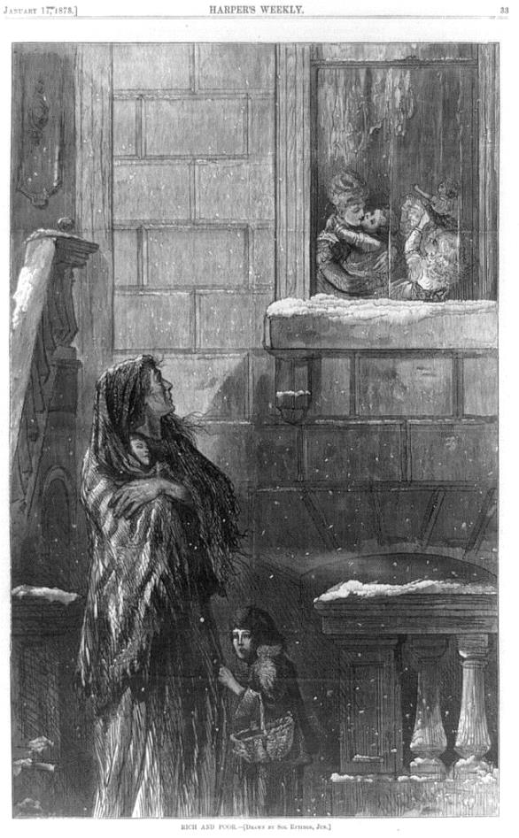
Herbert Spencer believed that the government should have only two purposes. One was to defend the nation against foreign invasion. The other was to protect citizens and their property from criminals. Any other government action was "over-legislation."
Spencer opposed government aid to the poor. He said that it encouraged laziness and vice. He objected to a public school system since it forced taxpayers to pay for the education of other people's children. He opposed laws regulating housing, sanitation, and health conditions because they interfered with the rights of property owners.
Spencer said that diseases "are among the penalties Nature has attached to ignorance and imbecility, and should not, therefore, be tampered with." He even faulted private organizations like the National Society for the Prevention of Cruelty to Children because they encouraged legislation.
In the economic arena, Spencer advocated a laissez-faire system that tolerated no government regulation of private enterprise. He considered most taxation as confiscation of wealth and undermining the natural evolution of society.
Spencer assumed that business competition would prevent monopolies and would flourish without tariffs or other government restrictions on free trade. He also condemned wars and colonialism, even British imperialism. This was ironic, because many of his ideas were used to justify colonialism. But colonialism created vast government bureaucracies. Spencer favored as little government as possible.
Spencer argued against legislation that regulated working conditions, maximum hours, and minimum wages. He said that they interfered with the property rights of employers. He believed labor unions took away the freedom of individual workers to negotiate with employers.
Thus, Spencer thought government should be little more than a referee in the highly competitive "survival of the fittest." Spencer's theory of social evolution, called Social Darwinism by others, helped provide intellectual support for laissez-faire capitalism in America.

Laissez-Faire Capitalism in America
Historians often call the period between 1870 and the early 1900s the Gilded Age. This was an era of rapid industrialization, laissez-faire capitalism, and no income tax. Captains of industry like John D. Rockefeller and Andrew Carnegie made fortunes. They also preached "survival of the fittest" in business.
American scholars like sociologist William Graham Sumner praised the new class of industrial millionaires. Sumner argued that social progress depended on the fittest families passing on their wealth to the next generation.
According to the Social Darwinists, capitalism and society itself needed unlimited business competition to thrive. By the late 1800s, however, monopolies, not competing companies, increasingly controlled the production and prices of goods in many American industries.
Workers' wages and working conditions were unregulated. Millions of men, women, and children worked long hours for low pay in dangerous factories and mines. There were few work-safety regulations, no worker compensation laws, no company pensions, and no government social security.
Although wages did rise moderately as the United States industrialized, frequent economic depressions caused deep pay cuts and massive unemployment. Labor union movements emerged, but often collapsed during times of high unemployment. Local judges, who often shared the laissez-faire views of employers, issued court orders outlawing worker strikes and boycotts.
Starting in the 1880s, worker strikes and protests increased and became more violent. Social reformers demanded a tax on large incomes and the breakup of monopolies. Some voiced fears of a Marxist revolution. They looked to state and federal governments to regulate capitalism. They sought legislation on working conditions, wages, and child labor.

Social Darwinism and the Law
Around 1890, the U.S. Supreme began aggressively backing laissez-faire capitalism. Supreme Court Justice Stephen J. Field asserted that the Declaration of Independence guaranteed "the right to pursue any lawful business or vocation in any manner not inconsistent with the equal rights of others . . . ."
The Supreme Court ruled as unconstitutional many state laws that attempted to regulate such things as working conditions, minimum wages for women, and child labor. The courts usually based their decisions on the Fifth and 14th amendments to the Constitution. These amendments prohibited the federal and state governments from depriving persons of "life, liberty, or property, without due process of law." (The Supreme Court interpreted "persons" as including corporations.)
In 1905, the U.S. Supreme Court used the "due process" reasoning to strike down a New York health law that limited the workweek of bakers to 60 hours. The majority of the justices held that this law violated the 14th Amendment's "liberty" right of employers and workers to enter into labor contracts. In a famous dissent, however, Justice Oliver Wendell Holmes criticized the majority decision. He said: "The 14th Amendment does not enact Mr. Herbert Spencer's Social Statics [one of Spencer's books on Social Darwinism]." [Lochner v. New York, 1905]
In 1890, reformers got Congress to pass the Sherman Antitrust Act. This law focused on "combinations" like monopolies (also called trusts). It banned them if they interfered with interstate commerce by eliminating competition and keeping the prices of goods high. When cases reached the Supreme Court, however, the justices largely ignored the control of consumer prices by monopolies. Instead, the justices focused on the behavior of "bad trusts" that used unfair tactics against competitors.
The Supreme Court limited the protest rights of labor unions in a 1911 case that outlawed some economic boycotts. The Supreme Court continued to make decisions that weakened unions until the 1930s.
Despite a hostile Supreme Court, Progressive Era reformers became increasingly successful in curbing the abuses of laissez-faire capitalism. For example, in 1906, Congress passed the Pure Food and Drug Act that prohibited companies from selling contaminated foods and misbranded drugs.
By 1912, both the federal government and many states had adopted Progressive reform legislation aimed at ending child labor and improving working conditions. That year saw three major candidates for president, all espousing Progressive ideas (Democrat Woodrow Wilson, Republican Howard Taft, and Progressive Theodore Roosevelt, who had broken from the Republicans because he believed Taft was not progressive enough). The idea of passing more laws to correct society's ills had replaced the Social Darwinist view that civilization best advanced when the "fittest" had their way while the "unfit" were allowed to die out. Americans had increasingly come to believe that society could choose its future, which might require government regulations on private enterprise.
In England, Herbert Spencer grew increasingly pessimistic as he witnessed a swelling tide of legislation that attempted to end the evils of industrialization and laissez-faire capitalism. Spencer died in 1903, and was buried in the same London cemetery as that great enemy of capitalism, Karl Marx.

For Discussion and Writing
- Social Darwinists believed that society naturally evolved by individual competition and the "survival of the fittest." Do you agree or disagree? Why?
- Do you agree or disagree with Herbert Spencer's view of government? Why?
- Would you support laissez-faire capitalism in the United States today? Explain.

Graphic: Herbert Spencer. By Engraved by Geo. E. Perine, New York. Public Domain, https://commons.wikimedia.org/w/index.php?curid=18913026

Graphic: Rich and poor / Redding, sc.; drawn by Sol Eytinge, Jun. Library of Congress. https://www.loc.gov/resource/cph.3b45184/

