Should Knives Ever Be Allowed at School?
The First Amendment of the United States Constitution’s Bill of Rights protects our right to practice the religion of our choice. The government cannot make laws that cause a person to not be able to follow his or her religious beliefs or practices, unless those practices cause direct harm to others.

Read the case below and be prepared to discuss this question: Should knives ever be allowed at school? Should the principal allow Rajinder to wear his kirpan?
-------------------------------------------------------------------------------------------------------------------

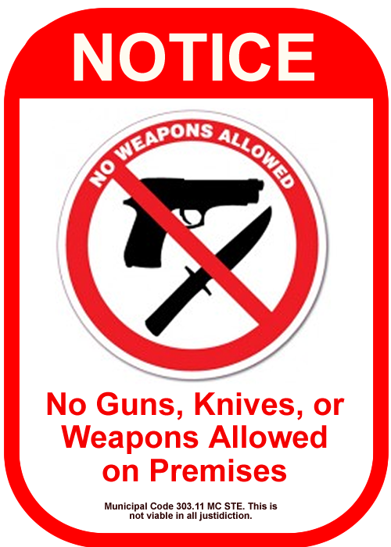
Fifth grader Rajinder Singh Cheema was playing basketball on the school playground. He had the ball and jumped up toward the hoop aiming for the basket. His shirt slid up. Under his shirt was a small knife strapped to his chest in its case. The school in California had a rule that said no weapons were allowed.

When the principal asked him why he brought the knife to school, Rajinder explained that it was part of his religion.

Rajinder is a Sikh, a religion founded in India 500 years ago. There are about 100,000 Sikhs in the United States. The knife (called a kirpan) symbolizes the religious duty to help people in need. It's a sacred symbol. In the Sikh religion, the kirpan is only to be used in a life or death matter. To Sikhs, wearing the kirpan at all times is very important. Some of the things that the kirpan stands for are:

- coming to the aid of a person who needs help.
- preventing violence from being done to a defenseless person.
- the power of truth.

Rajinder’s kirpan had a curved, rounded-edge and it was worn in a case. It hung around Rajinder's neck under his clothing.

At Rajinder’s school there was a very strict rule about weapons. No weapons of any kind were allowed at school. The principal was in charge of enforcing this rule. The purpose of the rule was to keep the students safe. Rajinder was not allowed to come to school with his kirpan because:

- no student can have any kind of knife, even a toy knife, at school.
- all of the students should feel safe while they are at school.
- students and parents need to feel sure that there are never any weapons on the school grounds.

Discussion Questions
1. Should knives ever be allowed at school?
2. Should the principal allow Rajinder to wear his kirpan?

