

# Immigration Enforcement Raids

**In the United States, there has been growing debate over the policies of the federal agency that investigates and enforces the nation’s immigration laws. That agency is** **Immigration and Customs Enforcement (ICE). Agents of ICE frequently conduct immigration enforcement operations, commonly called “raids,” in early morning hours to arrest undocumented immigrants.**

The ICE agency was formed in 2002. In the wake of the terrorist attacks of September 11, 2001, Congress created the Department of Homeland Security (DHS). This department was made responsible for enforcing the nation’s immigration laws, among other law enforcement powers. In this new organization of the federal government, ICE took over immigration law enforcement from the Immigration and Naturalization Service.

ICE currently manages law enforcement and investigation through different branches. Probably the most well-known branch of ICE is its Office of Enforcement and Removal Operations, which is responsible for investigation and arrests of unauthorized immigrants.

Once an unauthorized immigrant is arrested or detained, there are two ways that immigration officials may deport him or her:

* **Return.** When officials send a person to his or her home country *without* formal hearing, fingerprinting, or creation of a permanent record, it is called a “return.” An immigrant does not face potential criminal prosecution for re-entry to the US after a return to the home country.
* 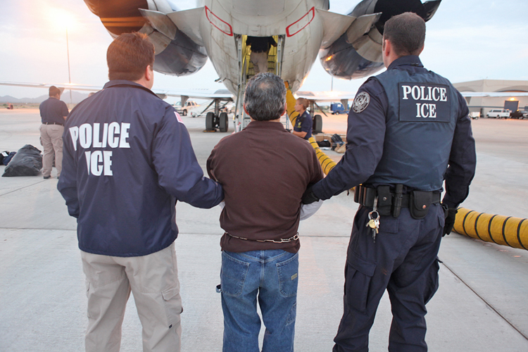**Removal.** When officials send a person to his or her home country *with* formal proceeding in front of a hearing officer (or judge), fingerprinting, and the creation of a permanent record, it is called a “removal.” ICE is responsible for removals, which is also the official term for “deportations.” An immigrant does face potential criminal prosecution for re-entry to the US after removal.

U.S. Dept. of Homeland Security, Bureau of Immigration and Customs Enforcement.

Answering a call for increased national security by many in the country, ICE started several programs, including the National Fugitive Operations Program (NFOP) in February 2002. This program’s mission was to “identify, locate, apprehend, process and remove fugitive aliens from the United States.” A fugitive alien is a person who has not followed an immigration court’s final order for removal or who has returned to the United States after a prior removal. Highest priority is placed on “those fugitives who have been convicted of crimes.” The program aims to eliminate a backlog of removals.

Increased federal funding for NFOP in the early years of Barack Obama’s presidency led to more immigrants being *removed* under Obama’s two terms as president than under George W. Bush’s two terms. More immigrants were *returned*, however, under Bush’s presidency.

Fugitive operations teams have used raids (quick arrests or “sweeps” of a number of immigrants in a single location). Raids can occur in a workplace, often of a large-scale employer, or residential area, such as an apartment building. Under the Bush administration, for example, ICE teams made 21 arrests of fugitive aliens from Jordan, Kuwait, and Somalia in northern Texas in November 2006. During the following month, ICE teams raided meat-packing plants in several states. Over 1,200 non-citizen employees were arrested, but ICE did not bring charges against the employer for having hired undocumented immigrants.

Case Study: San Rafael

A 2007 raid in San Rafael, California, sparked a national debate about ICE’s methods. On March 6, 2007, agents of ICE conducted a sweep of an apartment complex in this town of 56,000 people north of San Francisco. The agents arrived just after dawn in order to apprehend 30 fugitive aliens in the apartment complex. There were reports that agents shined flashlights into the faces of children in the apartments, handcuffed parents in front of children, and even detained children for several hours.

At a hearing before a subcommittee of Congress in May 2008 to address workplace immigration raids and specifically the effects of raids on children in the San Rafael congressional district, spokespeople on both sides of the issues testified.

Supporters of ICE’s methods argued that the undocumented immigrant parents have the primary responsibility for their children. In response to testimony critical of ICE, Republican Representative Buck McKeon argued that any child custody difficulties and humanitarian issues are the parents’ fault. “A person who entered the country illegally,” he said, “or overstays their visa—they are the ones who are really putting those children in jeopardy by their own actions.”

James Spero, Deputy Assistant Director at the ICE, testified that the agency’s teams go to great lengths to prepare for the humanitarian aid of children in the arrest operations. “ICE takes this responsibility very seriously,” he stated, “and these humanitarian factors are carefully taken into account when ICE makes custody decisions.” Part of what ICE agents do is to coordinate efforts with local public health services to care for children’s needs.

Critics of ICE’s tactics, such as Janet Murguia of the National Council of La Raza, testified that innocent children suffer too many hardships in these raids. Because many detained parents are denied access to telephones, no one calls family relatives to care for the children. As a consequence, said Murguia, “school systems and child care centers must scramble to find relatives or caregivers for children whose parents have abruptly disappeared.”

Lynn Woolsey, the Democratic representative for the San Rafael district, gave a statement at the hearing. She stated that the raids cause anxiety, depression, fear, and even post-traumatic stress disorder in children. “They have been separated from their families in the cruelest of ways for long periods of time,” she stated, “and many of their parents have been deported.” She further stated that the San Rafael raid led to dramatically decreased school attendance among the children involved.

The impact of ICE’s operations is still debated. On the one hand, ICE reports that its efforts target lawbreakers, particularly those who might pose threats to American society, such as gang members who are fugitive aliens. On the other hand, immigrants, their families, and civil liberties advocates have filed numerous lawsuits alleging that ICE operations have violated the US Constitution.

In one case, a 6-year-old boy named Kebin Reyes, a US citizen, sued ICE based on its San Rafael raid. Under the Fourth Amendment (protection against unlawful search and seizure), Kebin alleged that ICE agents detained him for 12 hours without a warrant and without lawful cause. Under the Fifth Amendment (protection of the right to due process of law), he alleged that he was deprived of food and the opportunity to make a phone call to any relatives.

In response, ICE stated numerous defenses for its actions. One defense was that ICE agents showed “due care and diligence” for Kebin Reyes before the raid and during the raid. Another defense was that the agency was protected by “sovereign immunity” (a doctrine that the state can do no legal wrong). ICE has also argued that Kebin’s injuries, through his father (who was arrested), were caused by his own negligence (lack of care).

Four months after the raid, ICE changed its policy to make sure not to detain US citizens, like Kebin Reyes, and legal residents during the course of enforcement raids. But at the time of the raid, ICE agents argue, Reyes’ rights had still not been violated. There have been no further hearings on the specific issue of immigration enforcement raids since 2008.

President Obama’s Policy on ICE Raids

Early in his presidency, Barack Obama shifted policy away from large-scale workplace raids to using monetary fines against employers who hired unauthorized immigrants. Under Obama’s administration, however, ICE used several residential raids to apprehend, or capture, fugitive aliens in January 2016 and took more than 120 Central American immigrants into custody in Georgia, Texas, and North Carolina.

The Obama administration defended its policy of using residential raids as a means to target fugitive aliens who have most recently entered the US, who happen to be mostly Central American. Of the thousands of families that migrated from Central America from 2014 to 2015, ICE took only 11 into custody in the raids. The US Border Patrol reported that Central American immigrants are mostly crossing the border in order to gain legal status in the US and not to seek political asylum (protection for refugees).

Opponents, including many Obama’s own Democratic Party, argued that Central American immigrants should be treated as refugees since they are fleeing from violence in their home countries. The newer immigrants came from countries like El Salvador and Honduras, which the US State Department has listed as countries dangerous to travel in. Also, many of them are children, and therefore vulnerable. The Border Patrol, say critics, is not equipped to properly evaluate refugee claims.

# For Discussion and Writing

1. What does “fugitive alien” mean?
2. Why is removal a more serious consequence than return for an unauthorized immigrant to the US?
3. What tactics does Immigration and Customs Enforcement use to apprehend fugitive aliens? What controversies have resulted from ICE’s tactics?
4. Opponents of ICE raids in residential areas claim that the human rights of children who may be fleeing dangerous home countries outweigh the fact that they and their parents may have violated valid court orders for removal back to their home countries. Do you agree? Explain your answer.
5. What are the opinions of both supporters and critics of ICE’s tactics in the San Rafael case study? Which side do you think has the stronger arguments? Why?

Sources

“Enforcement and Removal Operations.” U.S. Immigration and Customs Enforcement. URL: https://www.ice.gov/ero • “Fugitive Operations.” U.S. Immigration and Customs Enforcement. URL: https://www.ice.gov/fugitive-operations • “Hearing On: Immigration Raids: Postville and Beyond.” United States House of Representatives Judiciary Committee. 24–25 July 2008. URL: http://judiciary.house.gov • “ICE Workplace Raids: Their Impact on US Children, Families and Communities.” United States House of Representatives Subcommittee on Workforce Protections. 20 May 2008. URL: https://www.gpo.gov • “Kebin Reyes v. Alcantar.” *Closed Case*. ACLU of Northern California. 16 Sept. 2008. URL: https://www.aclunc.org • Lind, Dara. “The Nationwide Immigration Raids Targeting Central American Families, Explained.” *Vox*. 04 Jan. 2016. URL: http://www.vox.com • Zong, Jie, and Jeanne Batalova. “Central American Immigrants in the United States.” *Migrationpolicy.org*. Migration Policy Institute. 31 Aug. 2015. URL: http://www.migrationpolicy.org