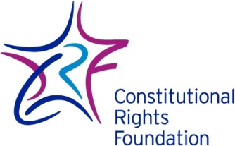
How Should We Judge Our Nation’s Founders?
Every generation reinterprets history. People, events, and institutions from the past are continually examined and re-examined. Their meaning and importance often cause debate. One question that has emerged recently concerns slavery.
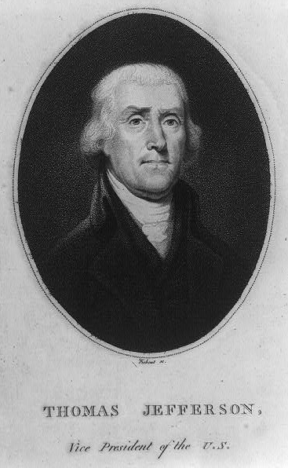
That “peculiar institution,” as our nation’s founders often referred to it, contradicted our creed of liberty for all. It divided our nation and led to the Civil War, the bloodiest war in our history. It continues to affect us today as we grapple with issues of prejudice, racism, intolerance, and inequality in America.
The legacy of slavery forces us to confront this question: How do we judge the founders of our nation who owned slaves? Thomas Jefferson, author of the Declaration of Independence and our third president, owned slaves. George Washington, revolutionary hero and first president, was one of the largest slave owners in the nation. James Madison, the prime architect of the Constitution and fourth president, held slaves. So did Patrick Henry, best remembered for saying “Give me liberty or give me death.” The same is true of George Mason, one of the most eloquent advocates for individual rights. In fact, 17 of the 55 delegates to the Constitutional Convention owned a total of about 1,400 slaves. Of the first 12 U.S. presidents, eight were slave owners.
Thomas Jefferson. Library of Congress. https://www.loc.gov/item/2004669139/
These men have traditionally been considered national heroes. Buildings, streets, cities, schools, and monuments are named in their honor. Does the fact that they owned slaves change our perception of them?
Some people believe that it should. They find it difficult to respect anyone who participated in slavery. They point out that many of the founders recognized slavery as evil but continued to own slaves. Instead of fighting the evil, they argue, these men actively participated in and benefited from it.
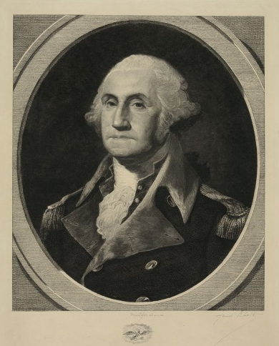
Many school districts throughout the South have changed the names of schools named for Confederate leaders who fought for the South in the Civil War. A school district in New Orleans, which has close to 90 percent black enrollment, has gone a step further. It has ordered the renaming of any school named after a slave owner.
George Washington. Library of Congress. https://www.loc.gov/item/2003670308/
This has meant that, in addition to changing schools named for Confederate leaders, schools named after other prominent slave owners have been renamed. George Washington Elementary School is now Dr. Charles Richard Drew Elementary, named for a prominent black surgeon. Carl Galmon, a civil rights leader who led the call for these changes asked, “How can we expect African–American students to pay homage and respect to someone who enslaved their ancestors?”
Others question this view. They contend that by honoring someone, we are not claiming the person is 100 percent perfect. Everyone has flaws. They say we must judge all persons by the age they lived in and by their achievements, looking carefully at their strengths and weaknesses. They point out that the founders lived in a society that allowed slavery, as had many societies up to that point in history. To hold this against them, they argue, would be unfair. Taking George Washington as an example, they see him as a great man of his era: Although he held slaves (which he freed at his death), he contributed greatly to America gaining its independence and to making America a democracy.

For Discussion
1. In a diverse society like America, there will always be debates over who we should or should not honor. When it comes to the men who founded our nation, what standards should we use to judge them?

2. Can we honor them for their contributions to our nation, or is the stain of slavery too great?

