Two Visions of Government

Thomas Hobbes (1588–1679)
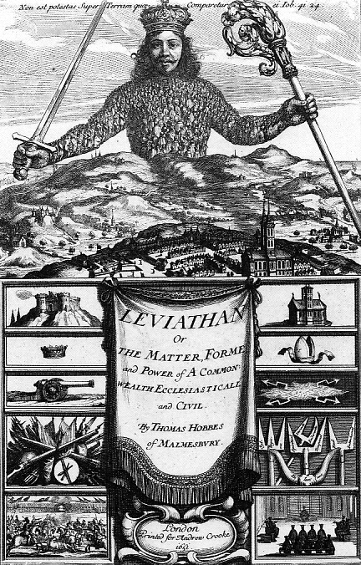
In 1642, a civil war broke out over who would rule England—Parliament or King Charles I. After nine years, the civil war finally ended with Parliament victorious. Charles was beheaded. Soon after, an English philosopher, Thomas Hobbes, wrote Leviathan. In it he made a defense of the absolute power of kings. The title of the book referred to a leviathan. This is a mythological, whale-like sea monster that devoured whole ships. Hobbes likened the leviathan to government, a powerful state created to impose order.

Hobbes began Leviathan by describing the state of nature where all individuals were equal. Every person did what he or she needed to do to survive. As a result, everyone suffered from “continued fear and danger of violent death” He thought that the life of man in a state of nature would be “solitary, poor, nasty, brutish, and short.”

In the state of nature, there were no laws or police to restore order. The only way out of this situation, Hobbes said, was for individuals to create a supreme power to impose peace on everyone.

Hobbes based his idea about forming government on English contract law. Hobbes said that the people agreed among themselves to “lay down” their natural rights of equality and freedom and give absolute power to a ruler, or sovereign. The sovereign, created by the people, might be a person or a group. The sovereign would make and enforce the laws to secure a peaceful society. This would make life, liberty, and property possible. Hobbes called this agreement the “social contract.”

Hobbes believed that a government headed by a king was the best form that the sovereign could take. Placing all power in the hands of a king, Hobbes argued, would mean more sure and consistent exercise of political authority. Hobbes also claimed that the social contract was an agreement only among the people and not between them and their king. Once the people had given absolute power to the king, they had no right to revolt against him.

Hobbes warned against the church meddling with the king’s government. He feared religion could become a source of civil war. He thought that the church should be a department of the king’s government. That way the king could closely control all religious affairs. In any conflict between divine and royal law, Hobbes wrote, the individual should obey the king or choose death.
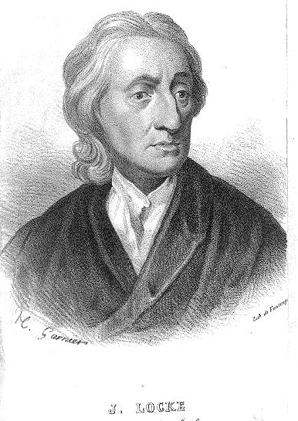
John Locke (1632–1704)
John Locke was born shortly before the English Civil War. Locke studied science and medicine at Oxford University and became a professor there. He sided with the Protestant Parliament against the English King James II in the Glorious Revolution of 1688. This event reduced the power of the king and made Parliament the major authority in English government.

In 1690, Locke published his Two Treatises of Government. He generally agreed with Hobbes about the brutality of the state of nature. He also agreed that a social contract was needed to assure peace. But he disagreed with Hobbes on two major points.

First, Locke argued that natural rights such as life, liberty, and property existed in the state of nature. He believed they could never be taken away or even voluntarily given up by individuals. These rights were “inalienable” (impossible to surrender). Locke also disagreed with Hobbes about the social contract. For him, it was not just an agreement among the people, but between them and the sovereign (preferably a king).

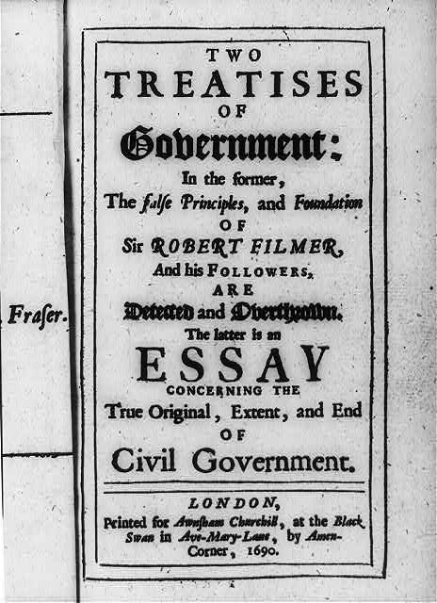
According to Locke, the natural rights of individuals limited the power of the king. The king did not hold absolute power, as Hobbes had said. Locke believed that the king acted only to enforce and protect the natural rights of the people. If a sovereign violated these rights, the social contract was broken. If this happened, the people had the right to revolt and establish a new government. Less than 100 years after Locke wrote his Two Treatises of Government, Thomas Jefferson used his theory in writing the Declaration of Independence.

Locke spoke out for freedom of thought, speech, and religion. But, he believed property to be the most important natural right. He declared that owners may do whatever they want with their property as long as they do not invade the rights of others. Government, he said, was mainly necessary to promote the public good. This meant protecting property, encouraging commerce, and little else. “Govern lightly,” Locke said.

Locke favored a representative government such as the English Parliament. It had two chambers. The House of Lords was made up of noblemen, who inherited their positions. The House of Commons was made up of members elected by voters. But he wanted representatives to be only men of property and business. Only adult male property owners, he believed, should have the right to vote. Locke was reluctant to allow the mass of people without property to vote or serve in government. He believed that they were unfit.

The supreme authority of government, Locke said, should reside in the law-making legislature, like England’s Parliament. The executive (prime minister) and courts would be creations of the legislature and under its authority.

For Discussion:

1. How are Hobbe’s and Locke’s vision of government similar? How are they different?

2. Which vision is better? Why?

Graphic: The frontispiece of the book Leviathan by Thomas Hobbes. https://commons.wikimedia.org/wiki/Thomas_Hobbes#/media/File:Leviathan.jpg

Graphic: John Locke, 1632-1704. Library of Congress https://www.loc.gov/item/2004672071/

Graphic: Title page of John Locke, Two Treatises of Government (London, 1690), Library of Congress. https://www.loc.gov/item/2002710224/

